**Practical-3**

**Aim: Draw the Structural View Diagram : Class Diagram.**

**3.1 Class Diagram:**

**3.1.1 Introduction:**

The class diagram is the main building block of object-oriented modelling. It is used both for general conceptual modelling of the systematics of the application, and for detailed modelling translating the models into programming code. Class diagrams can also be used for data modeling. The classes in a class diagram represent both the main elements, interactions in the application, and the classes to be programmed.

In the diagram, classes are represented with boxes that contain three compartments:

* The top compartment contains the name of the class. It is printed in bold and centered, and the first letter is capitalized.
* The middle compartment contains the attributes of the class. They are left-aligned and the first letter is lowercase.
* The bottom compartment contains the operations the class can execute. They are also left aligned and the first letter is lowercase.

In the design of a system, a number of classes are identified and grouped together in a class diagram that helps to determine the static relations between them. With detailed modelling, the classes of the conceptual design are often split into a number of subclasses.

**3.1.2 Symbols used in Class diagram:**

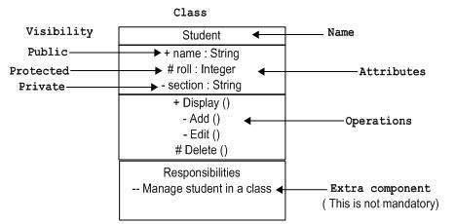

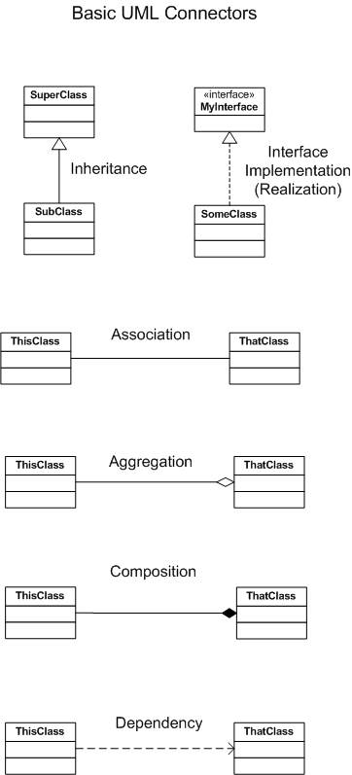

**3.1.3 Class diagram for PreMarriage System :**

